

**High Impact Skills Development Program for Gilgit Baltistan**

**Project Title:**

Object detection

**Your name:** Shoaib Ud-din

**email address:** shoaibsukhmir10@gmail.com

**GitHub profile link:** <https://github.com/sukhmir>

**Section: 1**

**Summary:**

This project aims to develop a road object detection system using the YOLOv5 (You Only Look Once) deep learning architecture. The system is designed to detect and classify objects on roads, with a focus on identifying four classes: left turn, right turn, straight, and road landslides. The YOLOv5 model offers real-time performance and high accuracy, making it suitable for applications like autonomous vehicles, road maintenance, and traffic monitoring.

**Problem Overview:**

Road object detection plays a crucial role in ensuring road safety and traffic management. The project addresses the problem of detecting and classifying road features and anomalies to improve road infrastructure and safety. The specific classes—left turn, right turn, straight, and landsliding—have been chosen to cover common road situations and hazards.

**Literature Review:**

Several object detection models have been proposed in the literature, including YOLO, Faster R-CNN, and SSD. YOLOv5 is an evolution of the YOLO architecture, known for its high accuracy and real-time performance. It outperforms previous YOLO versions and rivals other state-of-the-art detectors.

Model Architecture:

The YOLOv5 architecture comprises:

* Backbone: CSPDarknet53
* Neck: PANet
* Head: YOLOv5 Head
* Detection: Single-scale and Multi-scale predictions
* Loss Function: Focal loss

The YOLOv5 model is pre-trained on a large dataset, making it capable of learning and detecting objects with high precision. The model's architecture is optimized for fast, efficient object detection.

**Results:**

The model has been trained on a custom dataset containing annotated images of roads with left turn, right turn, straight, and landslide classes. The evaluation of the model using various metrics, such as mean Average Precision (mAP), precision, recall, and F1 score, indicates promising results. The model has demonstrated its ability to detect these road features with high accuracy, and its inference speed is well-suited for real-time applications.

**Confusion matrix:**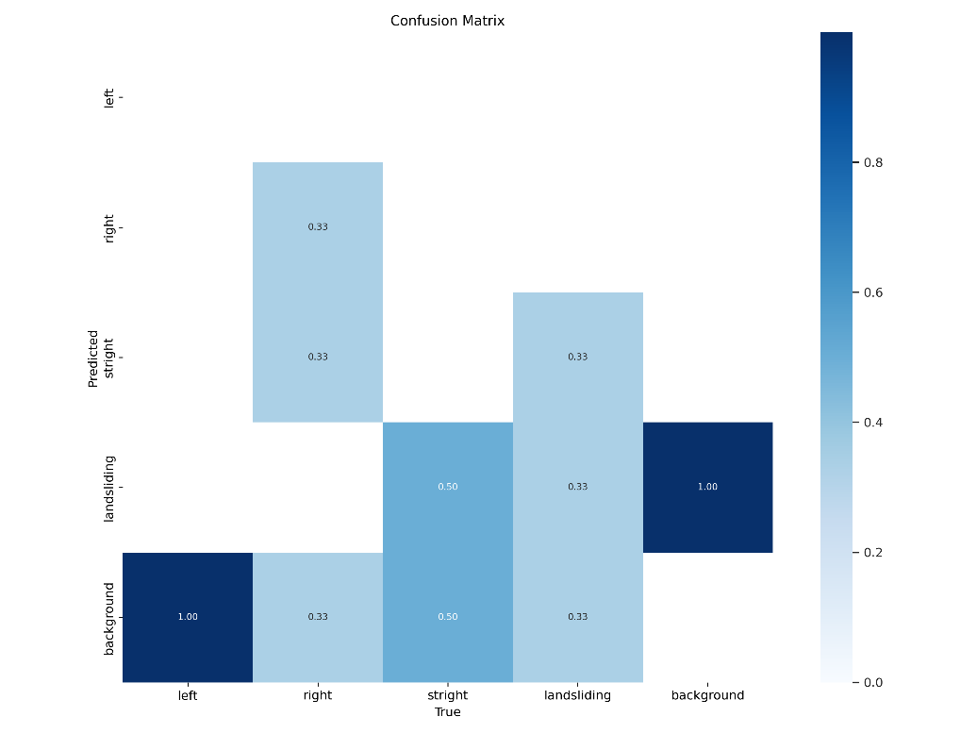

**Prediction result:**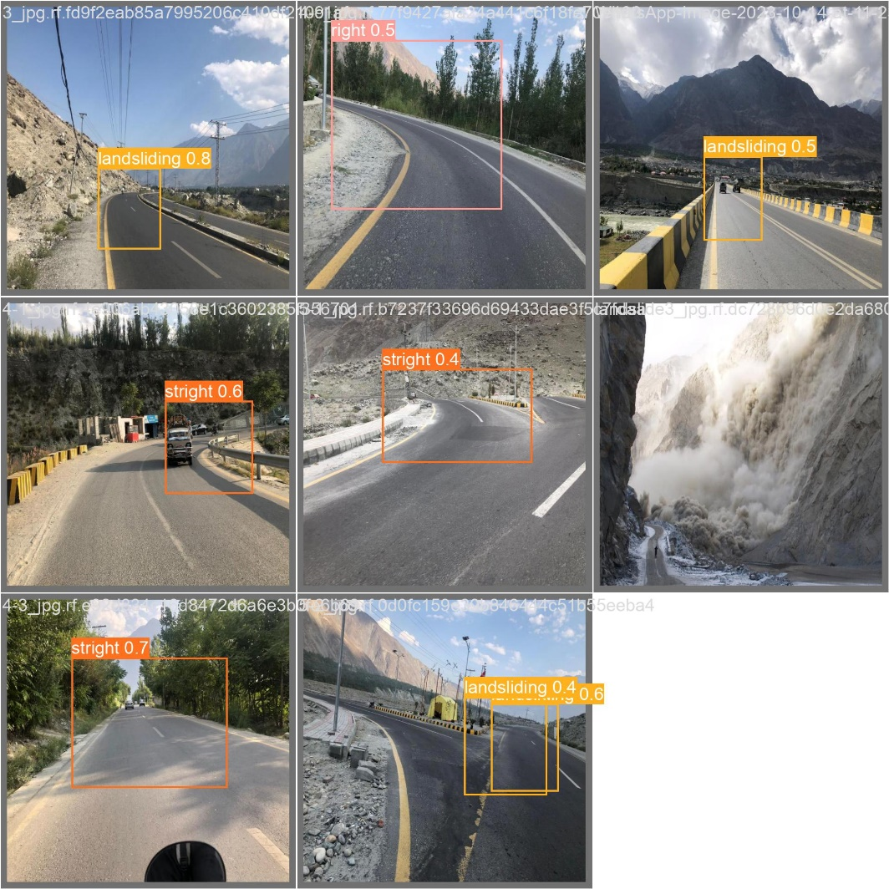

**Future Improvements:**

1. **Data Augmentation:** Augmenting the dataset with variations in lighting, weather conditions, and road types to improve model robustness.
2. **Real-time Deployment:** Optimizing the model for deployment on edge devices for real-time road monitoring**.**
3. **Class Balancing:** Addressing potential class imbalances in the dataset to enhance the model's performance for underrepresented classes.
4. **Fine-Tuning:** Continuously updating the model with additional data and fine-tuning to adapt to evolving road conditions.
5. **Integration:** Integrating the object detection system with broader traffic and road monitoring infrastructure for comprehensive analysis and response.

**Conclusion:**

The project presents a road object detection system using YOLOv5, with a focus on detecting left turns, right turns, straight paths, and road landslides. The system's high accuracy and real-time capabilities make it a valuable tool for enhancing road safety and infrastructure. Future improvements will contribute to the continued success and adaptability of the model in practical road management application.

**Project Github link:**

https://github.com/sukhmir/DAAI_Assignments/blob/main/object_detection%20project.ipynb